2.2 Project: Software Design; Interfaces & Polymorphism

Jessie Marie Sosniak

ECPI University

SDC330L: Object Oriented Programming using Java Lab

Mr. Randy Bellet

November 20, 2025

Classes
- Contact
Class Name: Contact
Purpose: Base class for all contact types, storing personal information such as name, phone, email, and address.
Functionality: Provides getters, setters, and a displayContact() method to output contact details.

- BusinessContact
Class Name: BusinessContact
Purpose: Derived class representing business-specific contacts, extending Contact with companyName.
Functionality: Adds companyName field and overrides displayContact() to include company details.

- AddressBook
Class Name: AddressBook
Purpose: Manages a collection of Contact objects using composition.
Functionality: Uses an ArrayList<Contact>, provides methods to add and display contacts.

- App
Class Name: App
Purpose: Entry point of the program, handling user interaction and tying together all other classes.
Functionality: Displays menus, processes input, and calls AddressBook methods.

Inheritance
- Base Class: Contact
- Derived Class: BusinessContact
- Shared Functionality: Name, phone, email, address fields, and displayContact() method.
- Unique Functionality: BusinessContact adds companyName and overrides displayContact() to include business details.
- Demonstration: BusinessContact inherits all fields and methods from Contact, then extends functionality with company-specific data.

Composition
- Example: AddressBook contains an ArrayList<Contact>.
- Reasoning: Contacts are logically grouped in an address book.
- Polymorphism: The ArrayList can store both Contact and BusinessContact objects. When displayContact() is called, the correct version executes depending on the object type.

Interface
- Interface Name: Verifiable
- Functionality Defined: isVerified()
- Reasoning: Each contact type should be able to verify its own data integrity. Contact checks that names and emails are valid, BusinessContact adds verification for companyName. This enforces consistency while allowing flexibility.
- Demonstration: Enables polymorphism, since AddressBook can call isVerified() on any contact without knowing its type.

Functionality by Class/Interface
- Contact: Stores and displays personal details, verifies basic data.
- BusinessContact: Adds company information, overrides display behavior, extends verification rules.
- AddressBook: Adds, stores, and displays multiple contacts.
- App: Provides user interface and menu navigation.
- Verifiable: Defines a contract for verifying contact information, enabling polymorphism across different contact types.

Polymorphism Demonstration
- AddressBook calls displayContact() on each Contact in its list. BusinessContact overrides this method, so polymorphism ensures the correct version runs.
- AddressBook can also call isVerified() on each Contact through the Verifiable interface, without knowing whether it is a Contact or BusinessContact.

Cohesion and Maintainability
- Contact handles personal data.
- BusinessContact extends Contact with business-specific details.
- AddressBook manages collections of contacts using composition.
- App provides user interaction.
- Verifiable enforces data integrity.
Responsibilities are clearly separated, making the system easier to maintain and extend. New contact types can be added by inheriting from Contact and implementing Verifiable, while AddressBook and App continue to operate without modification.
The program outline demonstrates inheritance, composition, abstraction, and polymorphism. Each class is purpose-driven, and the Verifiable interface ensures that all contacts can validate their own data. The design is intentional, maintainable, and provides a strong foundation for future enhancements such as new contact types, improved input handling, or integration with external storage systems.
SCREEN CAPTURES OF APPLICATION RUNNING: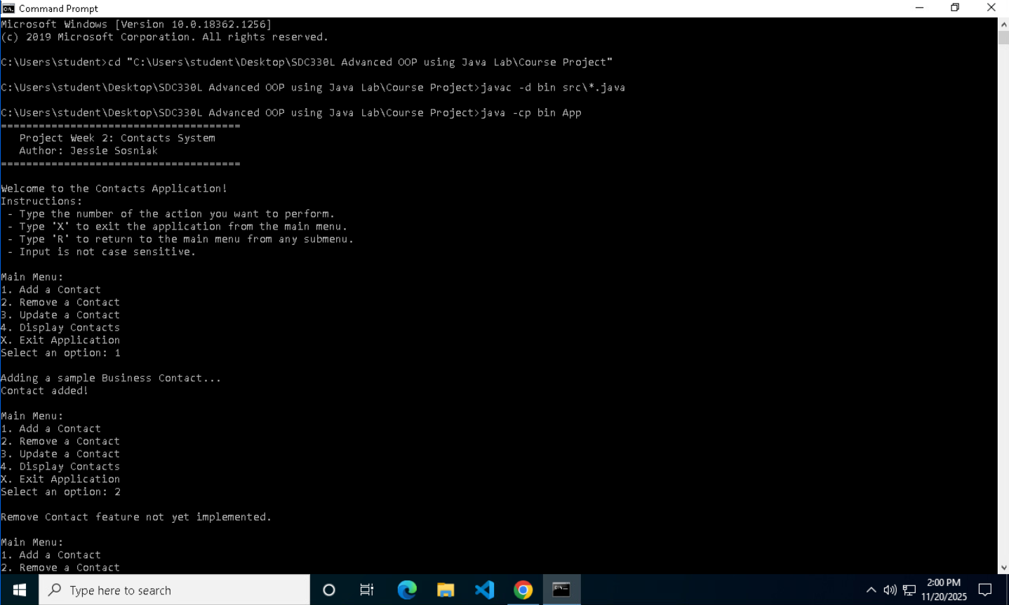 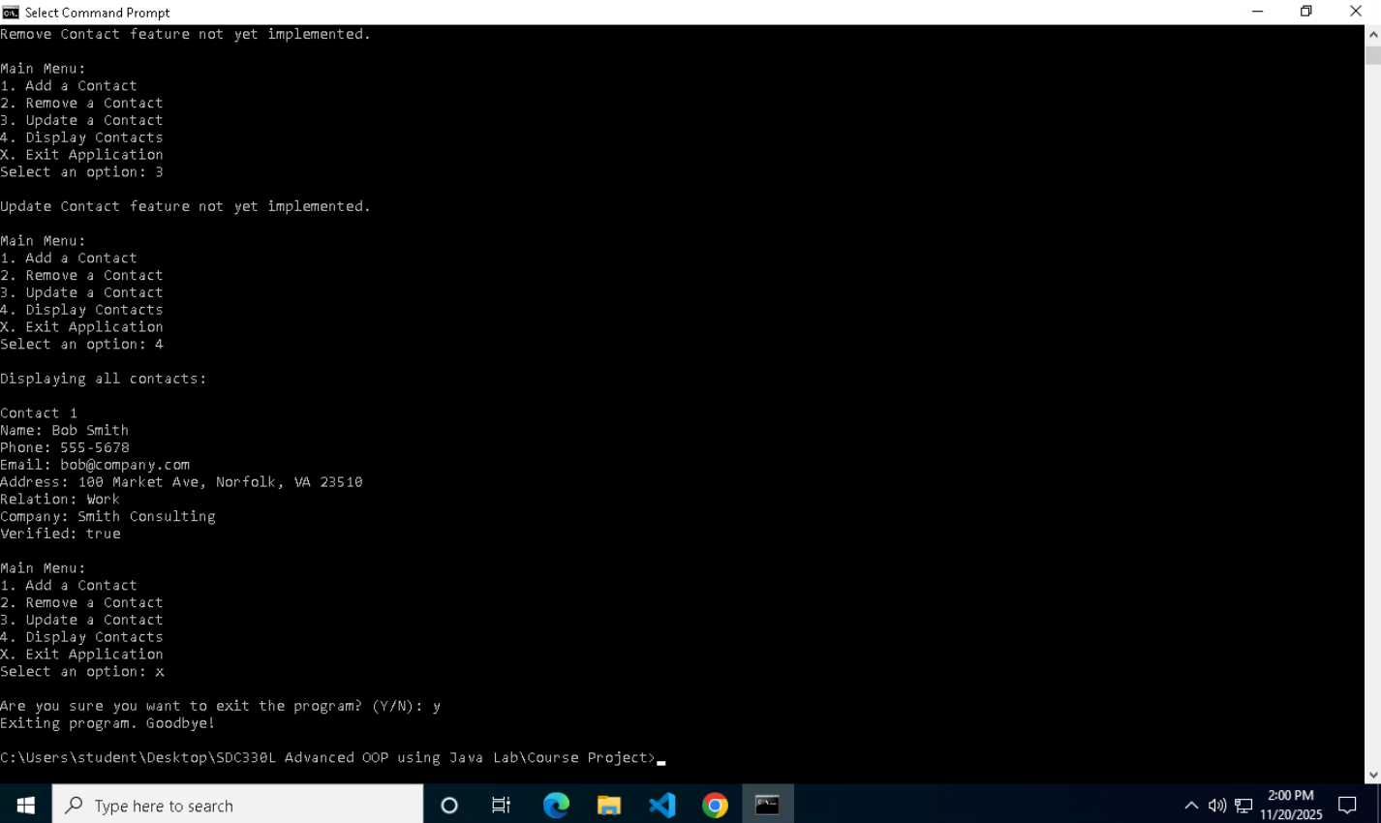
Note: I have been having troubles compiling the code through VSCode, so I have been doing so through Command Line. Not sure how to fix this problem, but Dr. Warner’s (teaching SDC330) students, including myself, been having troubles in VCastle when it comes to compiling through VSCode as well.
GITHUB LINK: https://github.com/Ecoz03/SDC330L-Advanced-Object-Oriented-Programming-Using-Java-Lab/releases/tag/Phase-2
Resources

